Spark Streaming Task
- Build a streaming application that reads real-time log data and counts the number of log levels (ERROR, INFO, WARN) continuously.
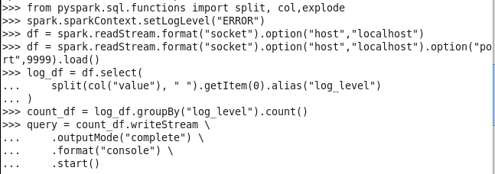

Output

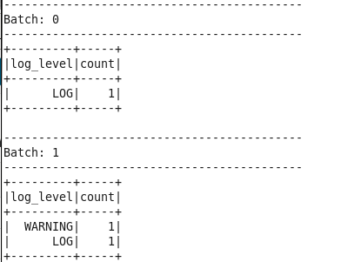

Port:
